Date:21-07-2020

ASSIGNMENT 1

**THE DOCUMENT OBJECT MODEL**

The Document Object Model, abbreviated DOM, is a powerful tree-like structure that allows programmers to conceptualize hierarchy and access the elements on a web page. The DOM is a logical tree-like **M**odel that organizes a web page’s HTML **D**ocument as an **O**bject. The DOM is implemented by browsers to allow for web scripting languages, like JavaScript, to access, modify, and update the structure of an HTML web page in an organized way.

The DOM tree follows similar logic to that of a family tree. A family tree is made up of family members and their relationships to the family name. In computer science, we would call each family member a node. In the DOM tree, the top-most node is called the root node, and it represents the HTML document. The descendants of the root node are the HTML tags starting with the <html> tag followed by the <head> and <body> tags and so on.

A parent node is the closest connected node to another node in the direction towards the root.

A child node is the closest connected node to another node in the direction away from the root.

**EXPLAIN STRUCTURE OF A WEB BROWSER**

**The user interface – provides a method with which a user interacts with a browser Engine. It includes the address bar, back/forward button, bookmarking menu etc. Every part of the browser display except the main window where we see the requested page.**

The browser Engine - marshals actions between the UI and the rendering engine.

The rendering engine - responsible for displaying requested content. For example if the requested content is HTML, the rendering engine parses HTML and CSS, and displays the parsed content on the screen.

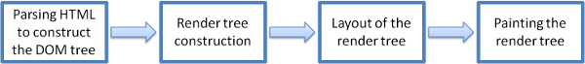

***RENDERING ENGINE BASIC FLOW***

Networking- for network calls such as HTTP requests, using different implementations for different platform behind a platform-independent interface.

UI backend- used for drawing basic widgets like combo boxes and windows. This backend exposes a generic interface that is not platform specific. Underneath it uses operating system user interface methods.

JavaScript interpreter- Used to parse and execute JavaScript code.

Data storage -This is a persistence layer. The browser may need to save all sorts of data locally, such as cookies. Browsers also support storage mechanisms such as localStorage, IndexedDB, WebSQL and FileSystem.

*It is important to note that browsers such as chrome run multiple instances of the rendering machine : one for each tab . Each tab runs in a separate process.*

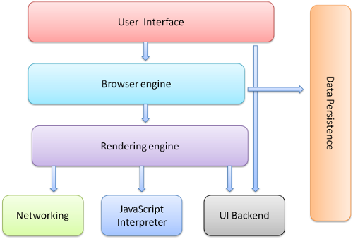

Architecture of Chrome
Rendering Engine:
Used the WebKit until
v27, from v28 user
WebKit fork Blink
XML Parser:
libXML to ...

PROGRAMS IN NODE JS

1. Sum of 5 numbers in an array

C:\Users\Subhangi>node

Welcome to Node.js v12.18.2.

Type ".help" for more information.

> var arr = [1,2,3,4,5];

undefined

> var sum = 0;

undefined

> for(let i = 0;i<arr.length;i++){

...

... sum = sum + arr[i]}

15

> console.log(sum);

15

Undefined

1. Get max of an array

> const inp = [5,4,6,9,10,13,12,21]

undefined

> console.log(Math.max(...inp));

21

undefined

**END**